# EXPERIMENT-26

# DATE;04-10-2025

**AIM**: CREATE A SQL STORAGE SERVICE AND PERFORM A BASIC QUERY USINGANY PUBLIC CLOUD SERVICE PROVIDER (AZURE/GCP/AWS) TO DEMONSTRATE DATABASE AS A SERVICE (DAAS)

# PROCEDURE:

STEP1: GOTO AZURE AND GOTO SQLDATABASE.

STEP 02: Now Create a Sql Databse

STEP3: SELECT THE RESOURCE GROUPAND ENTER THE SERVERNAMETHATAPPLICABLE. STEP4: IN NETWORKING SELECT ALLOW AZURE SERVICES AND

RESOURCES TO ACCESS THIS SERVER.

STEP5: IN ADDITIONAL SETTINGS SELECT SAMPLE. STEP6:AND THE SQL DATABASE IS DEPLOYED TEP7: NOW GOTO QUERY EDITOR.

STEP8:NOWAGAIN LOGIN TO THE SQLDATADATABASE

STEP9: OUR TABLES WILL SHOWN AND TYPE THE QUERY TO EXCUTED.

# IMPLEMENTATION:

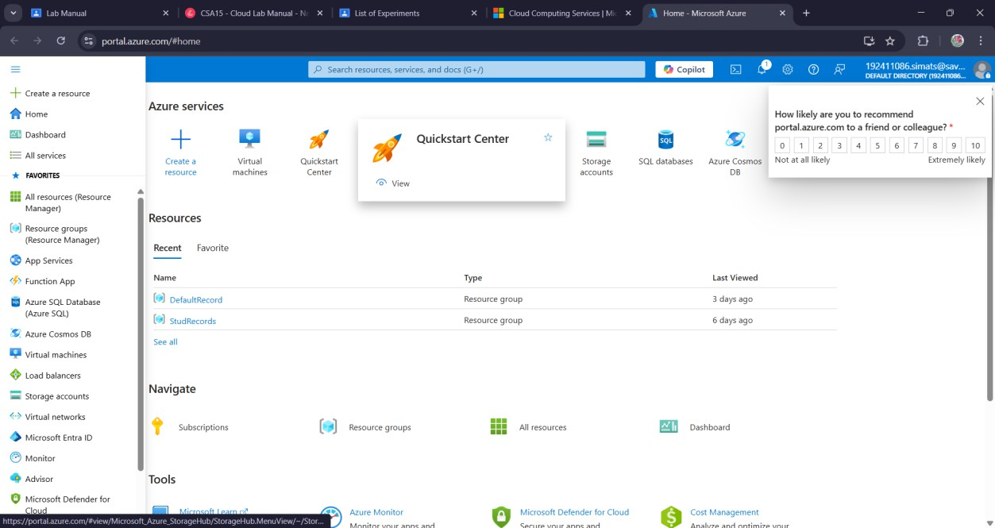

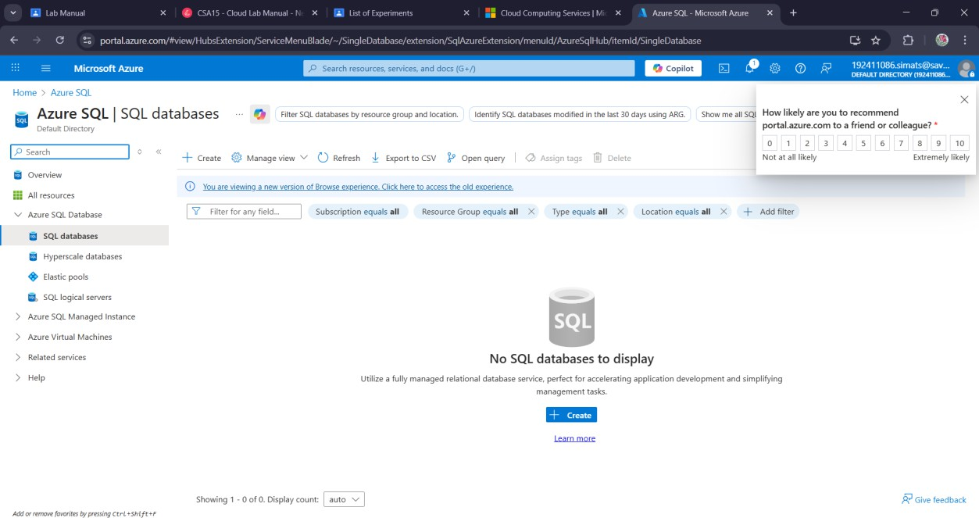

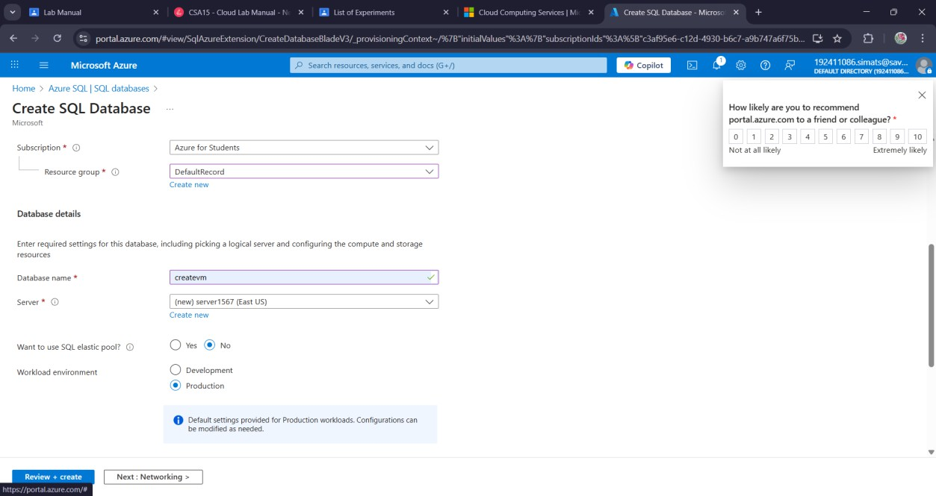

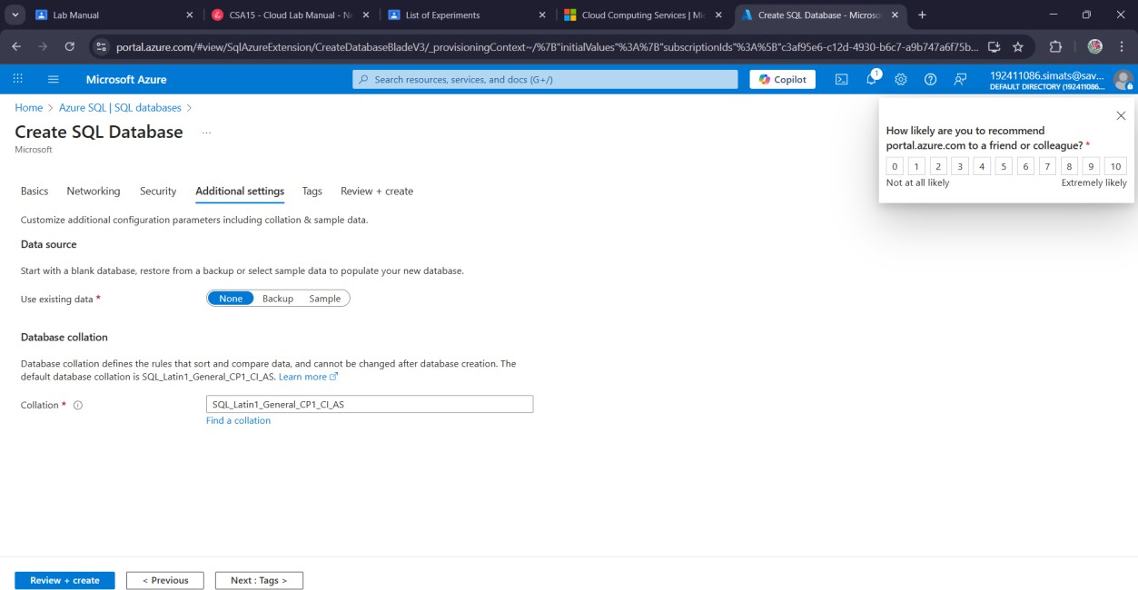

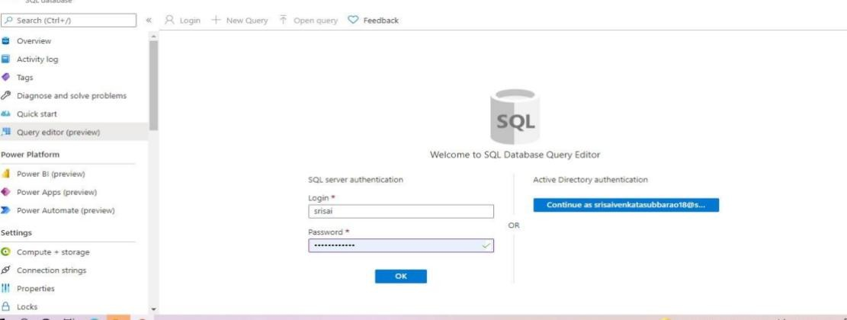

**Result:**

a sql storage service and perform a basic query usingany public cloud

service provider (azure/gcp/aws) to demonstrate database as a service (daas) has been created.